1. Clone project from GitHub
   1. Use a protected location that you can keep consistent
   2. This will make development easier for you since you can push and pull with the GitHub desktop app
   3. And your Eclipse workbench will be able to find new files when you pull a new branch
   4. This will make parallel development easier
   5. I’m using my desktop

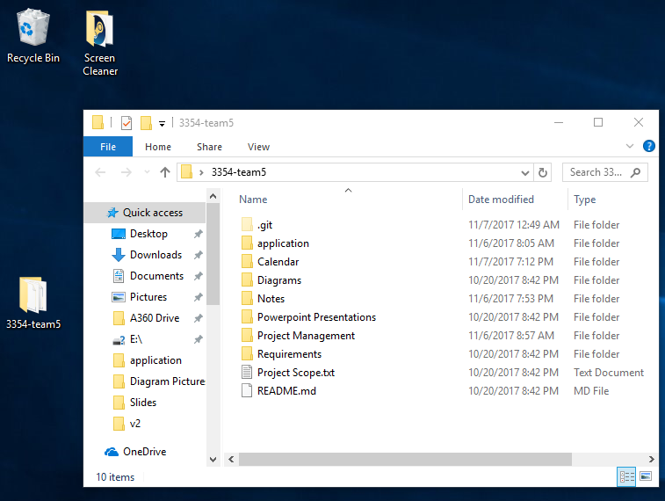

1. Open Eclipse
2. Delete any existing projects with name calendar
   1. Case does not matter, remove them
3. Click File -> New -> Java Project

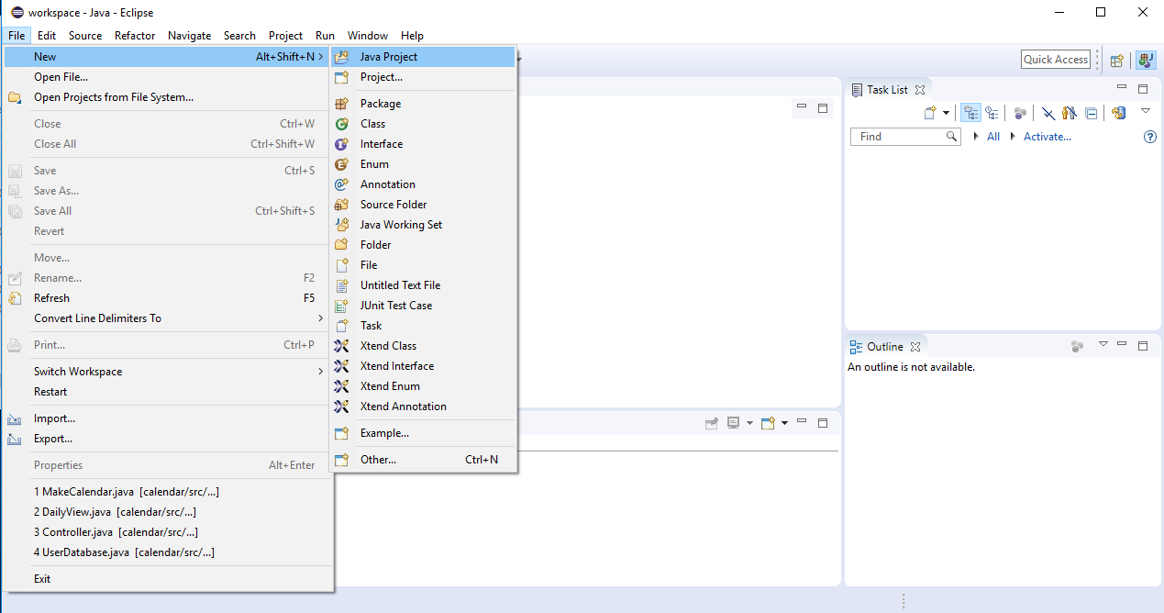

1. Make sure the red boxes on the right project screen are filled out as in the image
   1. The left is showing how my GitHub folder is setup

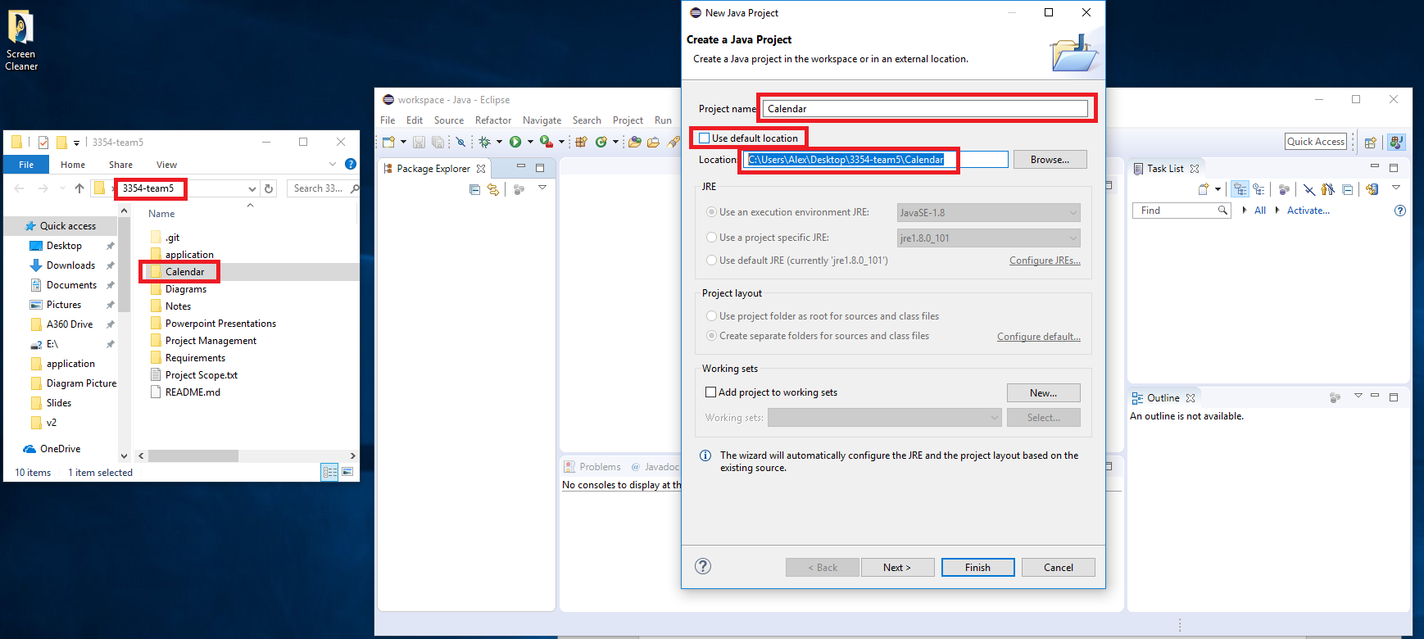

1. Keep your GitHub folder in the same location and your project will always be able to find the needed files
   1. Example of Calendar working

